

IAB206 ASSESSMENT TWO

Technical Report Task 2



September 11, 2019

SEMESTER TWO

Jiyan Zhu, Shu Du, Gayan Iresh Gunathilaka

Contents

Task 2 2

Create: 2

5 create queries in order to insert the data 2

read queries 4

Update quires 7

Delete a record 12

# Task 2

## Create:

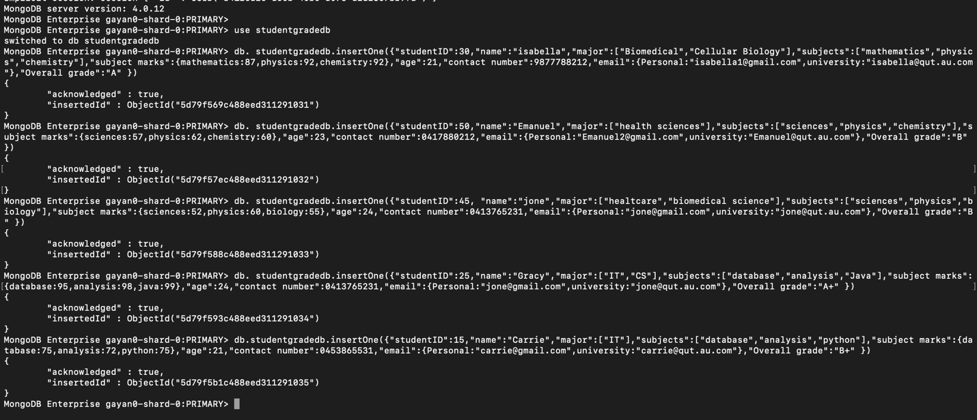

## 5 create queries in order to insert the data

*db.studentgradedb.insertOne({"studentID":30,"name":"isabella","major":["Biomedical","Cellular Biology"],"subjects":["mathematics","physics","chemistry"],"subject marks":{mathematics:87,physics:92,chemistry:92},"age":21,"contact number":9877788212,"email":{Personal:"isabella1@gmail.com",university:"isabella@qut.au.com"},"Overall grade":"A"})*

*db.studentgradedb.insertOne({"studentID":50,"name":"Emanuel","major":["health sciences"],"subjects":["sciences","physics","chemistry"],"subject marks":{sciences:57,physics:62,chemistry:60},"age":23,"contact number":0417880212,"email":{Personal:"Emanuel2@gmail.com",university:"Emanuel@qut.au.com"},"Overall grade":"B"})*

*db.studentgradedb.insertOne({"studentID":45,"name":"jone","major":["healthcare","biomedical science"],"subjects":["sciences","physics","biology"],"subject marks":{sciences:52,physics:60,biology:55},"age":24,"contact number":0413765231,"email":{Personal:"jone@gmail.com",university:"jone@qut.au.com"},"Overall grade":"B"})*

*db.studentgradedb.insertOne({"studentID":25,"name":"Gracy","major":["IT","CS"],"subjects":["database","analysis","Java"],"subject marks":{database:95,analysis:98,java:99},"age":24,"contact number":0413765231,"email":{Personal:"gracy @gmail.com",university:"gracy@qut.au.com"},"Overall grade":"A+"})*

*db.studentgradedb.insertOne({"studentID":15,"name":"Carrie","major":["IT"],"subjects":["database","analysis","python"],"subject marks":{database:75,analysis:72,python:75},"age":21,"contact number":0453865531,"email":{Personal:"carrie@gmail.com",university:"carrie@qut.au.com"},"Overall grade":"B+"})*

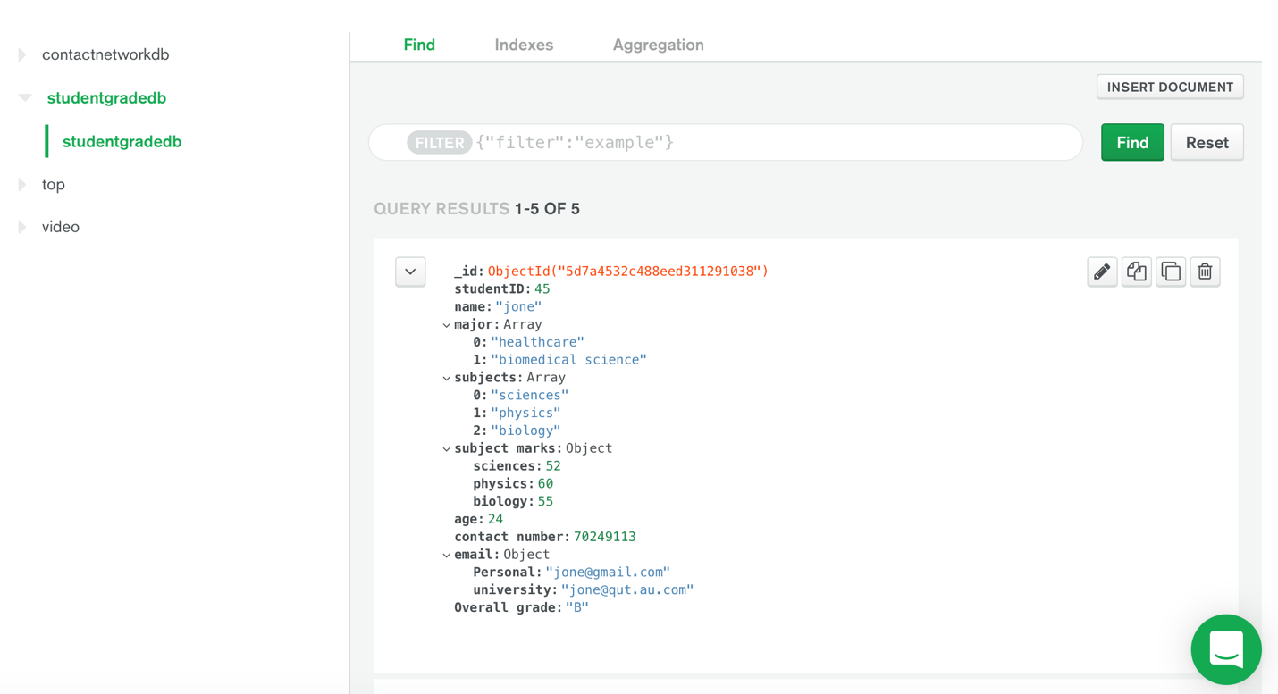

## read queries

**Name of the Student whose name has “bella” in between her name**

*db.studentgradedb.find({$and:[{ 'name': /.*bella.*/}]}).pretty()*

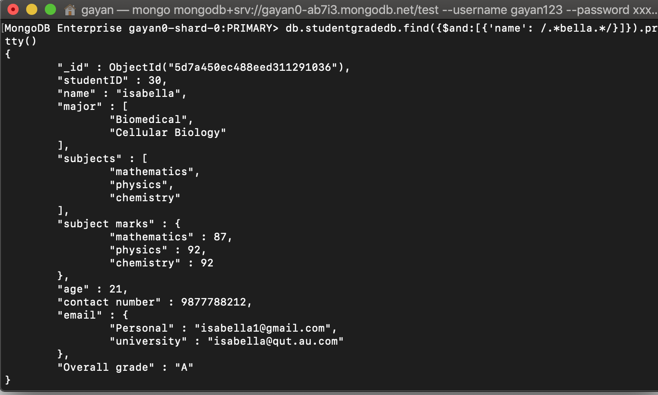

**Students having grade A+**

*db.studentgradedb.find({"Overall grade":"A+"}).pretty()*

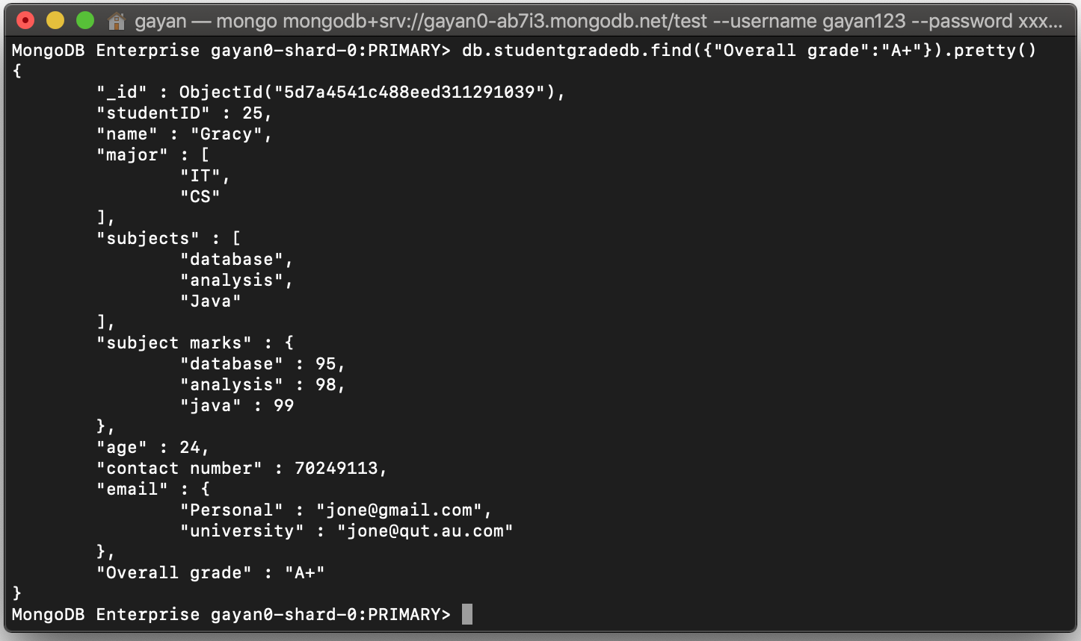

**All major IT students.**

*db.studentgradedb.find({major:{$all:["IT"]}}).pretty()*

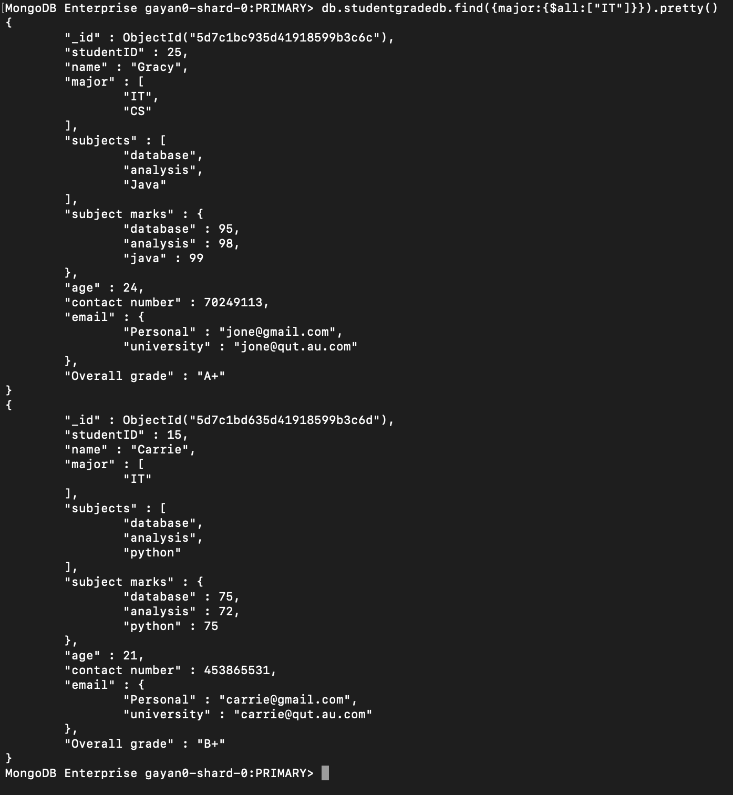

## Update quires

**Before update**

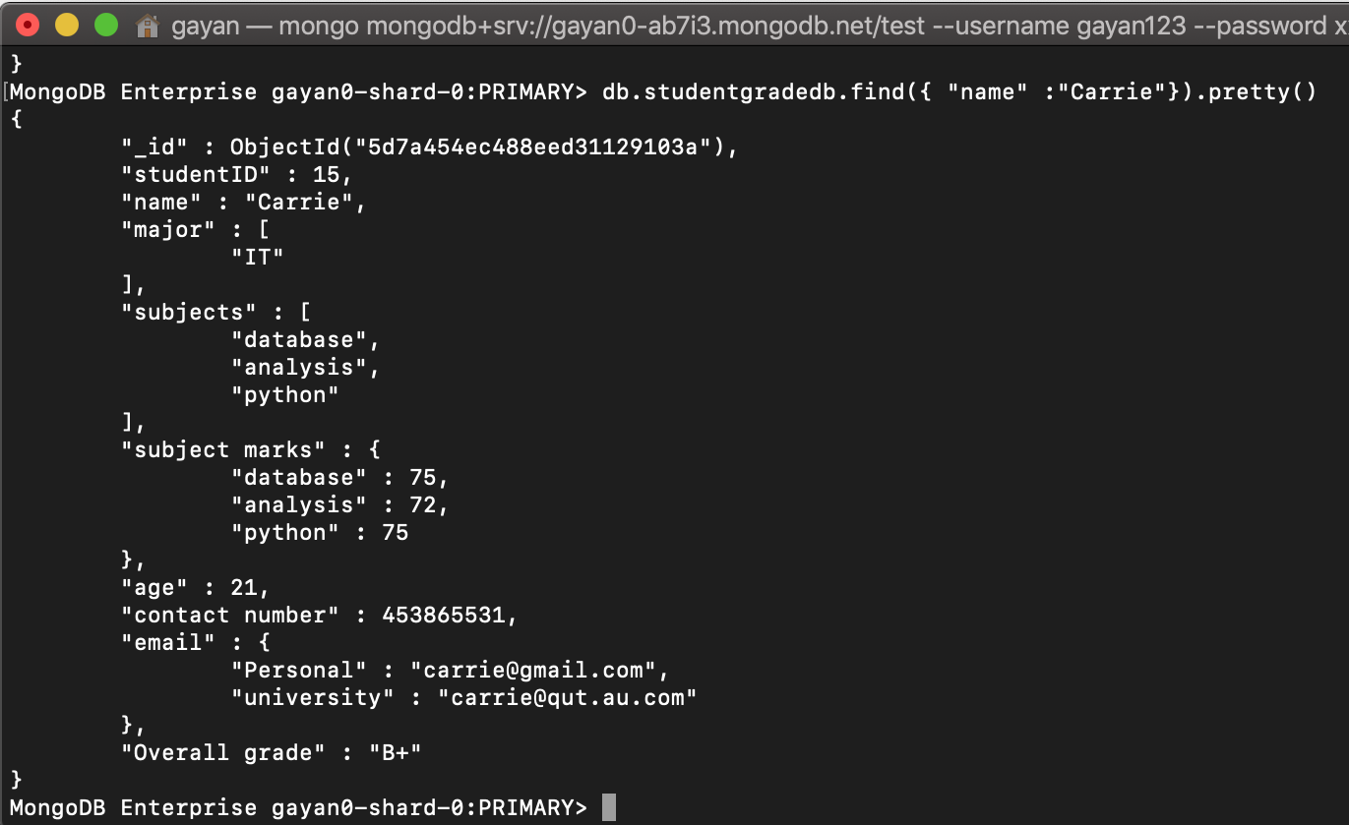

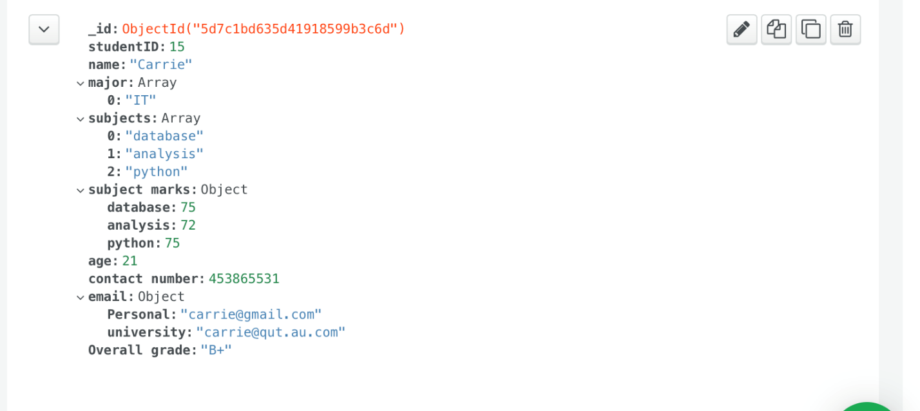

**Update score student of a carrie**

db.studentgradedb.updateOne({name:"Carrie"},{$set:{'subject marks':{database:88, analysis:87,python:86}}})

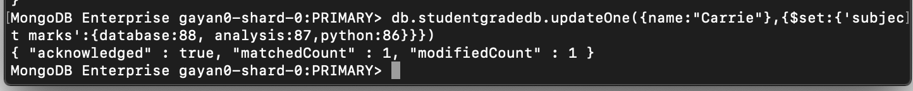

**After update**

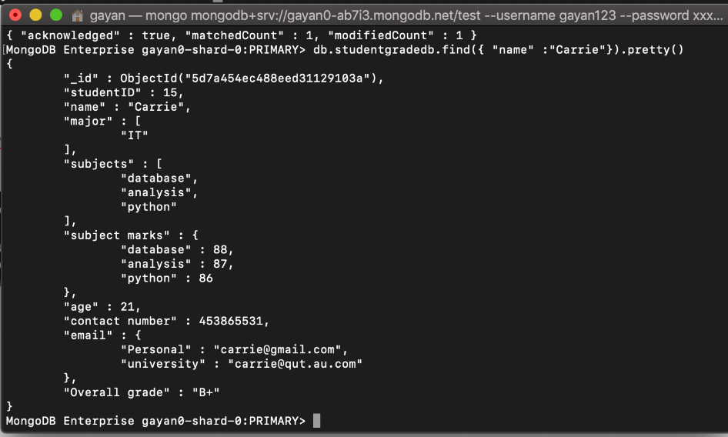

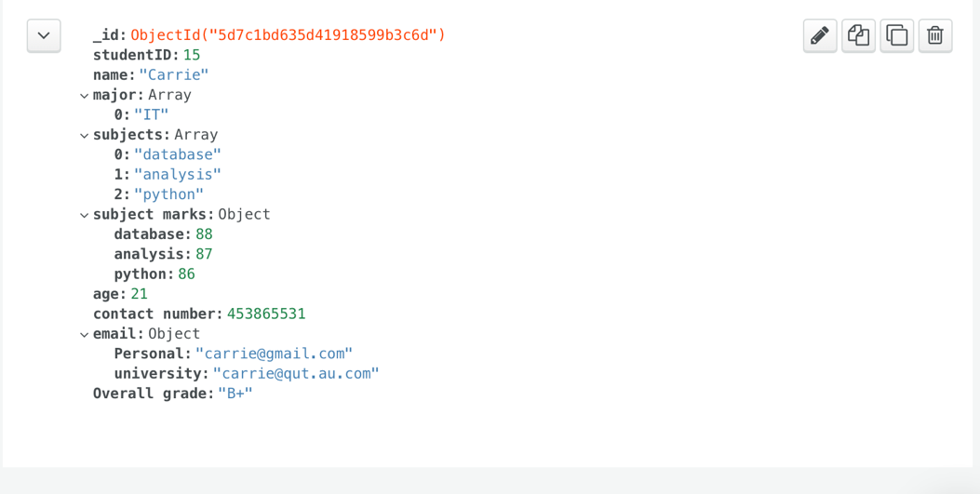

**Before update overall grade**

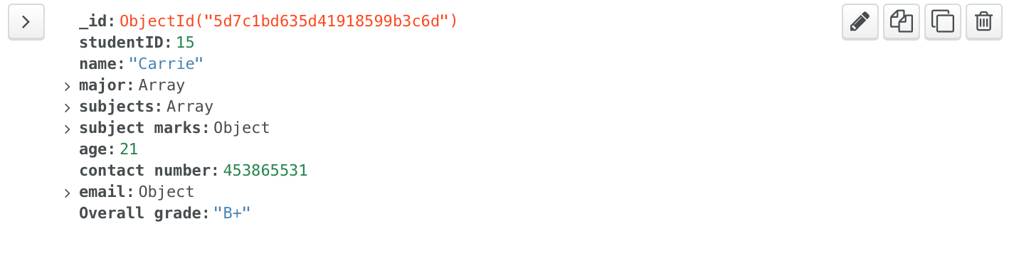

Update overall grade student of the carrie

*db.studentgradedb.update({name:/.*Carrie*./},{$set:{"Overall grade":"A"}})*



**After update overall grade**

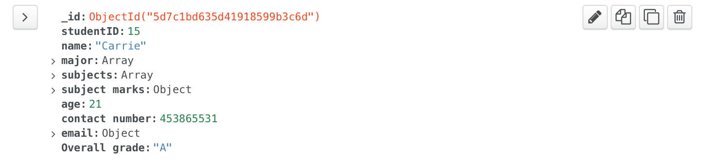

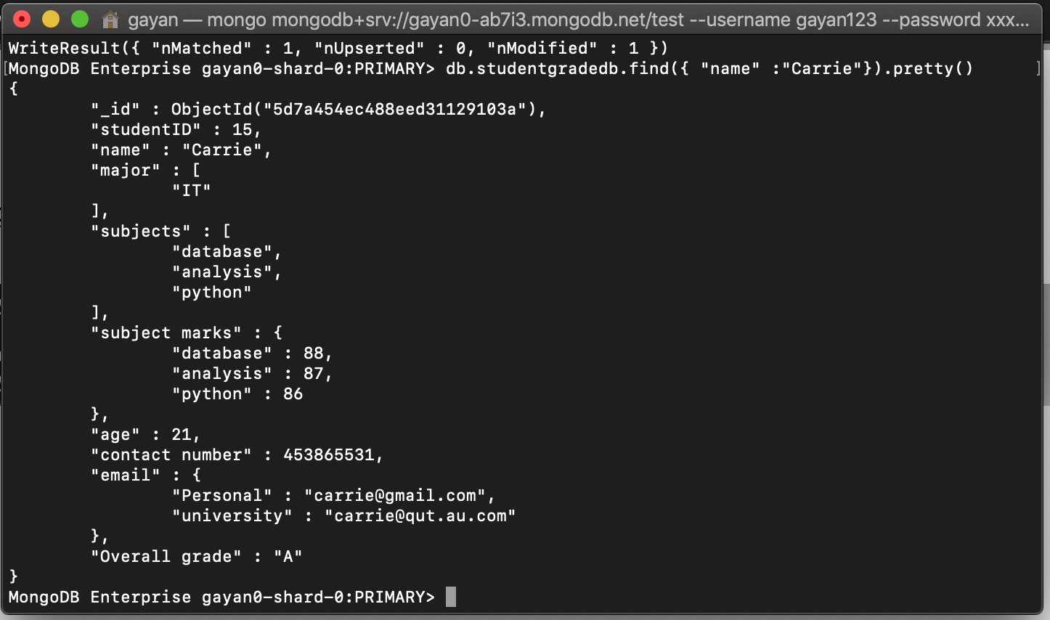

Update carrie full name carrie

**Before Update**



*db.studentgradedb.update({name:"Carrie"},{$set:{name:"Carrie Higgens"}})*

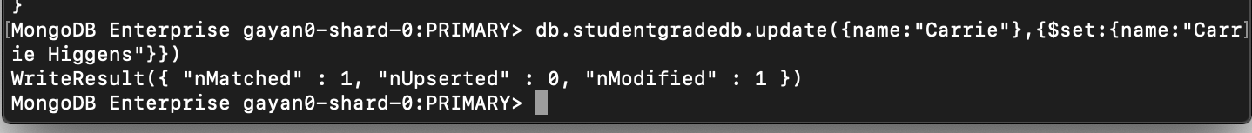

**After update**

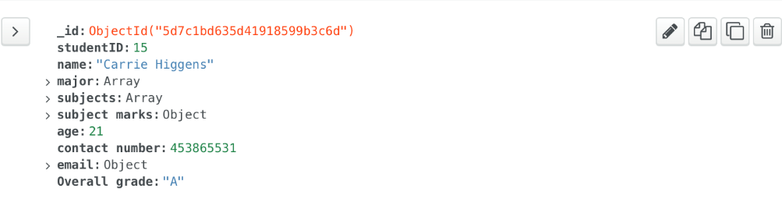

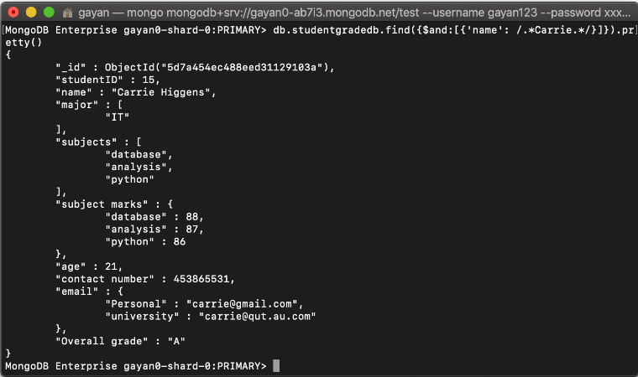

## Delete a record

Before Delete a record



**Overall grade B all the students remove**

*db.studentgradedb.remove({"Overall grade":"B"})*



After Overall grade B all the students delete



